# **Prerequisite Check**

Before you proceed any further, it's vital to confirm that you've successfully completed the setup for your front-end, back-end, and database according to the instructions outlined in the README.md file. If you haven't done so yet, please revisit the README.md and ensure those setup tasks are completed.

# **Introduction**

Welcome to HOPLA Notes, a technical assessment document dedicated to evaluating and assessing your skills. HOPLA Notes is a streamlined web application designed for the creation and organization of notes. This assessment will challenge you with a series of tasks directly related to HOPLA Notes, providing you with the opportunity to showcase your technical proficiency and expertise.

To proceed with the technical assessment, please create an account in HOPLA Notes

1. In HOPLA Notes, click the **Create an account** button

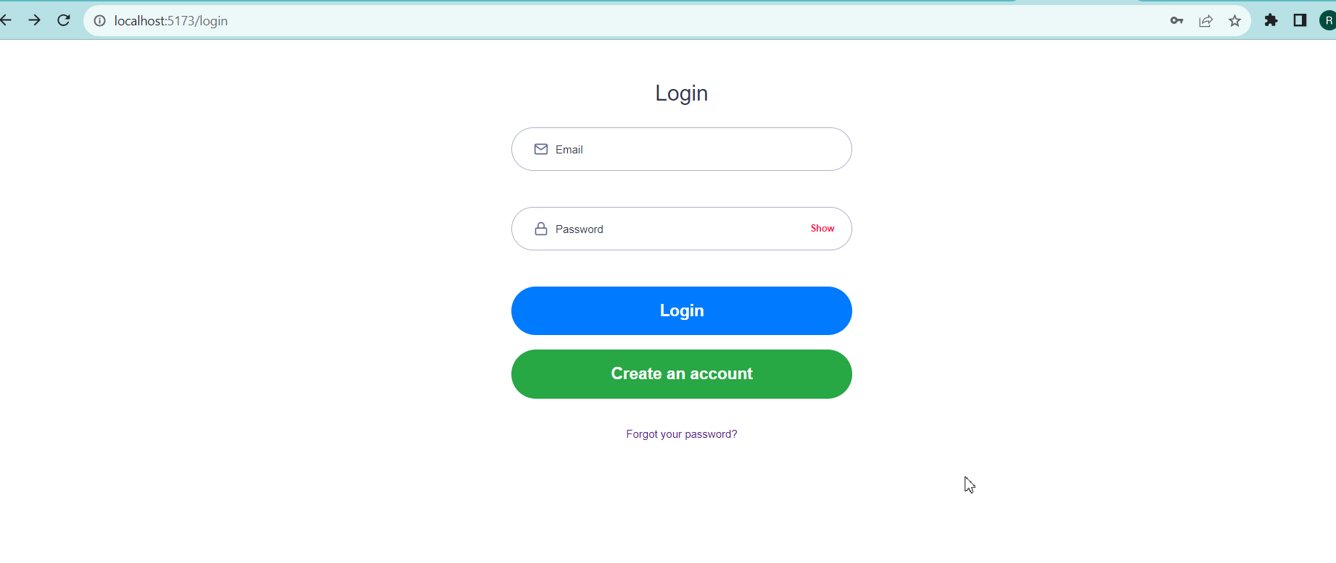

1. You will be redirected to the **Register** page. Provide your **Email** and **Password** and click the **Register** button

3.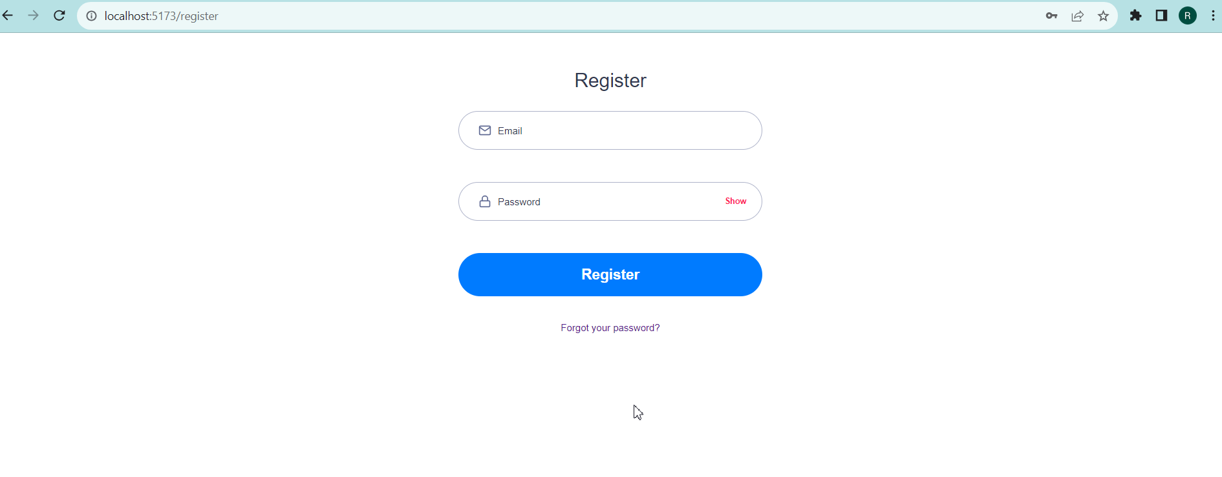

3. Go back to the **Login** page and type in your registered **Email** and **Password**. Upon successful login, you will be redirected to the **Home** page

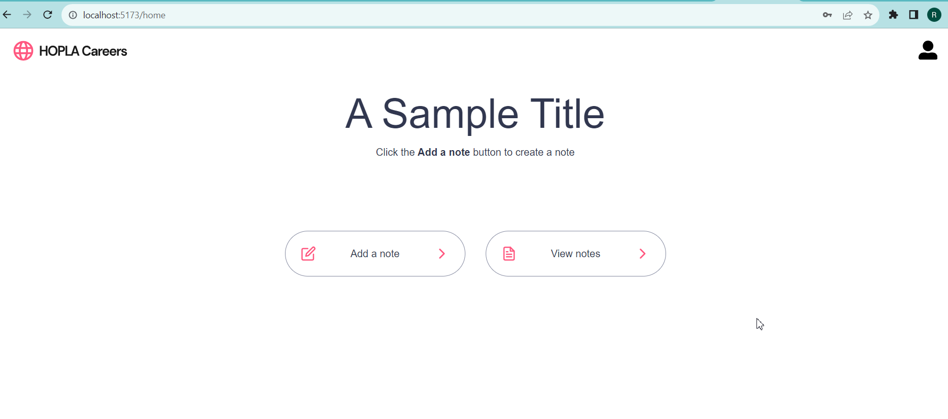

# **Back-end Task #1 – Implement Add note functionality**

1. Click the **Add a note** button to access the **Add note form**

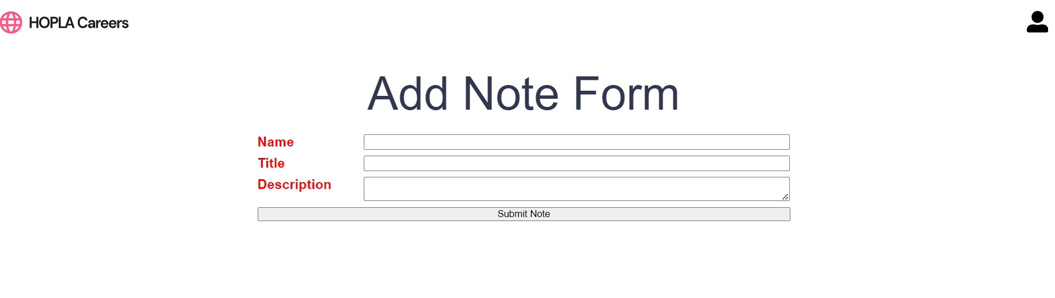

1. Implement a functionality that would create a new note when the **Submit Note** button is clicked. The newly added note should appear when you click the **View notes** button

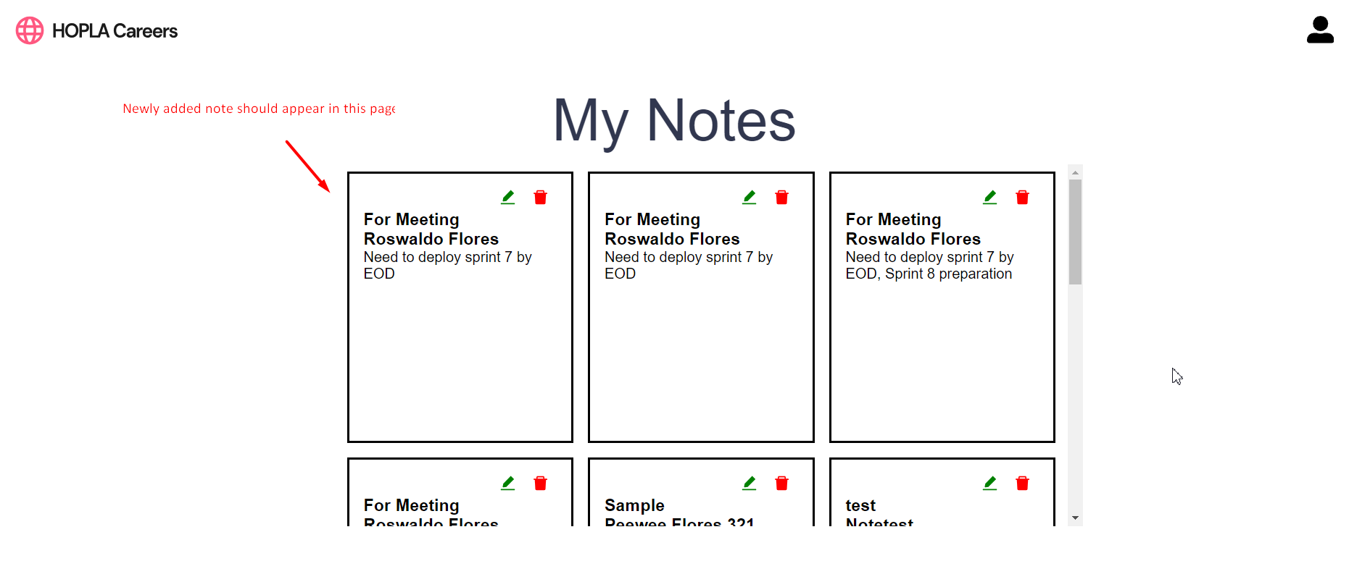

# **Back-end Task #2 – Implement Edit note functionality**

1. In the **My Notes page**, Click the  button to open the **Edit Note form**

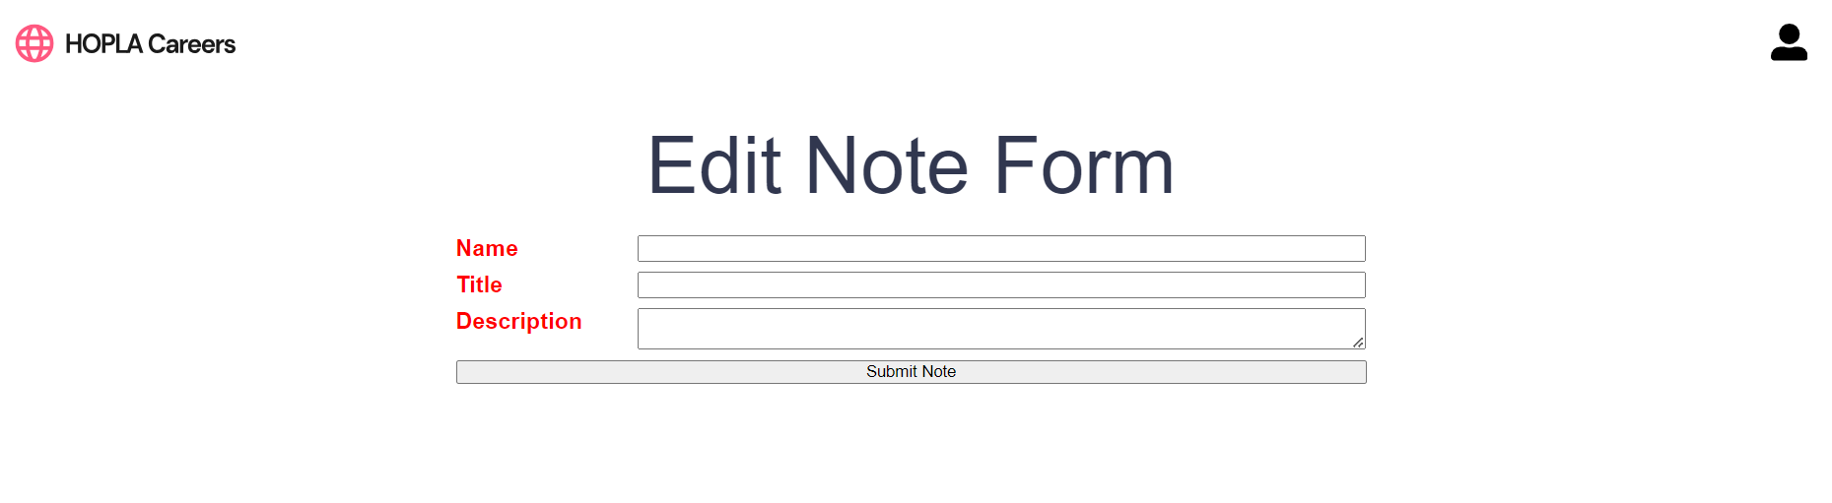

1. Implement a functionality that would modify a note’s name, title, and description based on the content of the **Edit Note form**

# **Back-end Task #3 – Implement Delete note functionality**

1. In the **My Notes page**, Click the  button to open the **Delete Note modal**

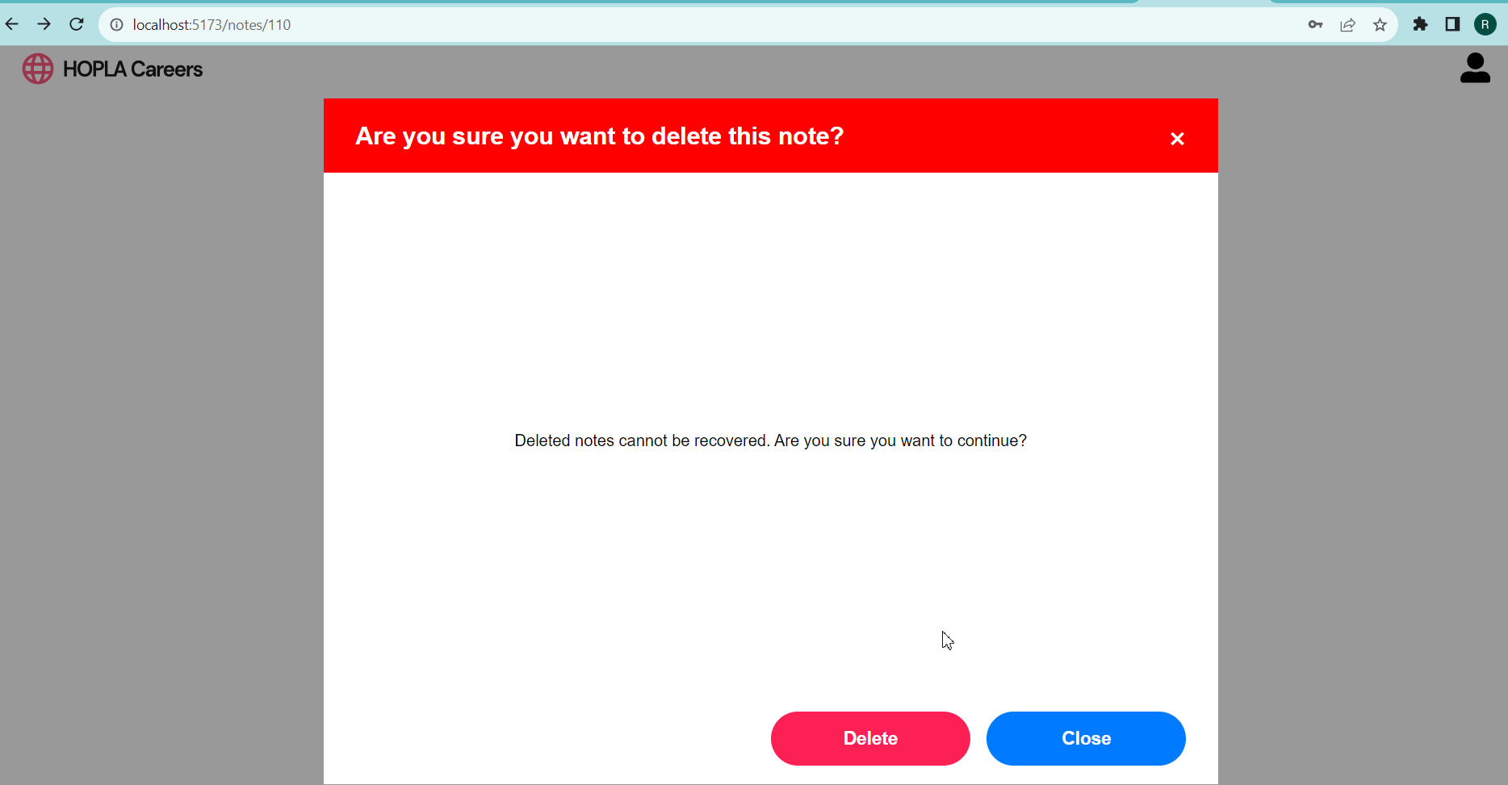

1. Clicking the **Delete** button should remove the note from the **My Notes page**

# **Submission**

After completing the tasks, please submit your work by creating a new pull request. We will thoroughly review your code and respond promptly.